Title or Task: | Photoshop
Description: | Using the selection tools select various elements from the following files

Files Required
Suitable for Classes: | Multimedia, Small Business, Applied Information Technology Certificate II
Area: | Technology & Enterprise (ICT)
Teacher: | Mr Peter Faulks
Timeline | 2 lessons (this lesson requires 2 sessions)
Date Due: | In class
Task Brief: | This session requires some skill in using the mouse and various selection tools, it is used to take students through some basic aspects of Photoshop. It was based on Photoshop CS3 so some variations will occur if using other versions. It is rated easy and should give students confidence in starting Photoshop

Development or Outcomes:

Items highlighted in yellow are tasks for you to complete


Items in Blue italics are help tips

These pages are designed to show you how to use software packages; various software updates may have taken place so some pages will not apply to versions other than those listed here. In some cases data files may be required.

Copy these images to your folder or download the Photoshop_Images.zip

At the end of this document are some help pages that revise some of the tool functions

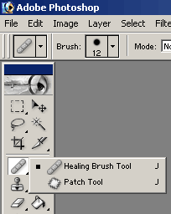

110 Photoshop Healing patch Tool
Photoshop The Healing Brush & Patch Tool

The Healing Brush and the Patch tool are new with PS 7

The Healing Brush tool lets you correct imperfections, causing them to disappear into the surrounding image. Like the cloning tools, you use the Healing Brush tool to paint with sampled pixels from an image or pattern. However, the Healing Brush tool also matches the texture, lighting, transparency, and shading of the sampled pixels to the source pixels. As a result, the repaired pixels blend seamlessly into the rest of the image.

Select the Healing Brush tool Healing Brush tool .

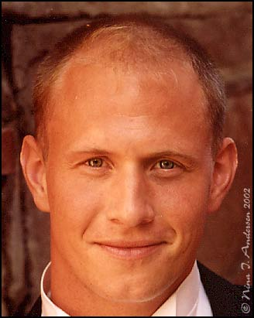
The Healing Brush works the same way as the Clone Stamp tool, but the healing brush tool also matches the texture, lighting, and shading of the sampled pixels to the source pixels. This means that the repaired pixels blend seamlessly into the rest of the image. And this is what makes this tool so incredible powerful when it comes to restoring and retouching pictures.

A tip along the way:
Be sure you always keep a copy of the original file. Either do a "save as" before you start editing the picture - or just drag the original layer down to the Create a new layer tab to create a copy you can work on.

Choose a blending mode from the Mode pop-up menu in the options bar:

* Choose Replace to preserve noise, film grain, and texture at the edges of the brush stroke.
Select Aligned in the options bar to sample pixels continuously, without losing the current sampling point, even if you release the mouse button. Deselect Aligned to continue to use the sampled pixels from the initial sampling point each time you stop and resume painting.
For the Healing Brush tool in sampling mode, set the sampling point by positioning the pointer in any open image and Alt-clicking (Windows)

# Drag in the image.
The sampled pixels are melded with the existing pixels each time you release the mouse button. Look in the status bar to view the status of the melding process.

Select the Healing Brush tool and adjust the brush size etc. so it will suit the areas you're going to work on. I started out working on the lines on the forehead using a brush with these settings.
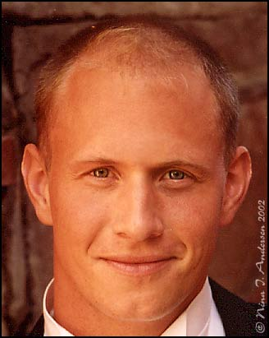
PS! Be sure you have marked the Sampled option to use pixels from the current image.

After you've entered the brush values (or just picked one of the default ones) you have to pick a sampling point by positioning the pointer in an area of the image that has about the same qualities as the area you want to fix.
Click Alt + left click the area you want as source and then click and drag the brush over the part you want healed.
(You can check the Aligned option in the Healing Brush status bar to keep the current sampling point. If deselected the sampled pixels are applied from the initial sampling point each time you stop and resume painting).

If you're not happy with the outcome go back - select a new sampling area and drag the brush over the area you want healed all over again. Do this until the lines are gone and the skin tones look realistic.

Now - this is REALLY important. Be sure to create a snapshot of your work at this state. You'll soon understand why...
The Create a new Snapshot is found on the History palette - to the left of the "trash can"/Delete current state button.

Time to use the Patch tool .

I wanted to get rid of the dark puffy areas below the eyes - and the Patch tool does this in a few seconds!
Select the Patch tool and be sure the Source option is checked in the tool options bar. Then select the area you want to fix (left click and drag out the selection).

(You can also use the Lasso tool to drag out the selection if you want - just remember to switch to the Patch tool when you're done...)
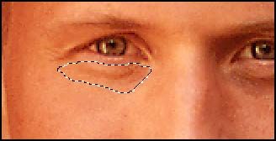
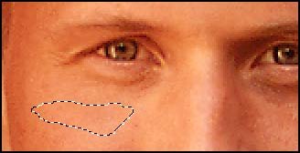

Now drag the selection to an area that has about the same color and texture as the area you want to replace - and just release the mouse button.

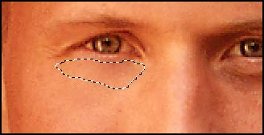
The original area below the eye is now automatically replaced!
Deselect the selection and do the same process on the other eye.
Deselect again.

In step 6 you can see what my image looked like at this point.
The wrinkles below the eyes are totally gone and the new "skin" blends perfectly.
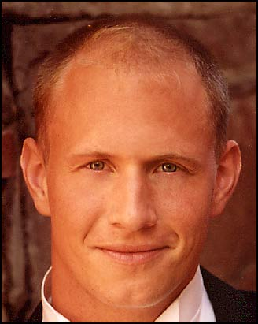

BUT - it really looks kind of fake.
To make the retouch look more real we can use the History Brush tool to paint some of the old details below the eyes back on.

And this is why I told you to Create a snapshot in step 2.

Before you go any further be sure to create another snapshot.

(I always take a lot of snapshots while doing photo retouch. Makes it so easy to go back and do things all over again if you're not happy with the outcome...).

Select the History Brush tool .
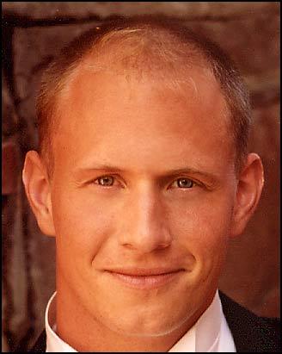
Then go to the History palette and check the box to the left of your first snapshot like shown below:
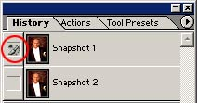

(If you accidentally activate the Snapshot 1 state just click the Snapshot 2 state - or just go down in the History window and click on the latest action before you continue).

Select a brush that suits the area you're going to work on. Click here to see what kind of brush settings I used for this area. As you can see I lowered the opacity to 21%. That's
because I just wanted to paint some of the details back.

Now use the brush below the eyes and carefully "paint" some of the details back!
You see my result after using the History Brush tool to the left.

Original picture
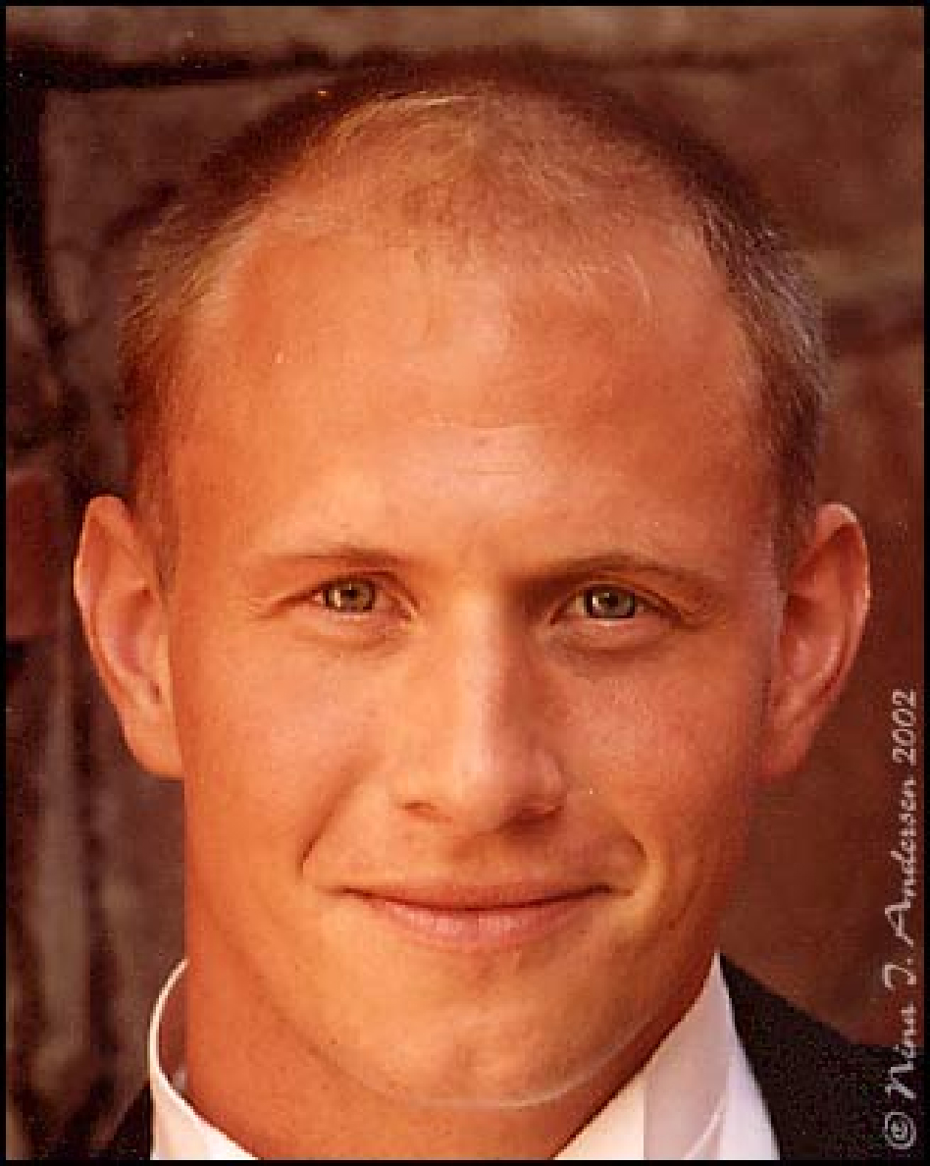
This is how the picture looked right from the scanner. Before I started using healing brush tool I did and Image - Adjustments - Auto Color to get rid of the magenta color cast on the picture. Then did an Auto Brightness/Contrast and an Auto Levels. That did the trick for this particular picture. To sharpen the picture a little bit I used the Unsharp mask (Filter - Sharpen - Unsharp mask) with these settings. (Note that different pictures need different unsharp mask settings...). Then I added a Hue/Saturation adjustment layer and added just a little more color. The rest of the process editing this picture is described in the steps above.

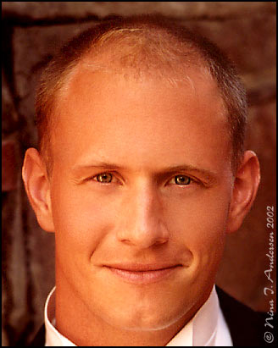

Final image

This is how my picture turned out in the end. I continued working on it just using the Healing Brush tool after the last step. Just working on small skin areas at the time to get rid of the irregularities of the skin. Making the skin look really smooth and flawless.
When I finished working on the face I used the Blur tool to smoothen out the details in the background to make it blend with the rest of the image. I'm really happy about the final result though there's still some flaws that could be worked on some more :)
Hope you got familiar with the Healing Brush tool and the Patch tool going through this tutorial. If you have any questions please post them in the forum.

http://www.eyesondesign.net/pshop/healing/brush.htm

Using the Patch tool (Photoshop)

The Patch tool lets you repair a selected area with pixels from another area or a pattern. Like the Healing Brush tool, the Patch tool matches the texture, lighting, and shading of the sampled pixels to the source pixels. You can also use the Patch tool to clone isolated areas of an image.
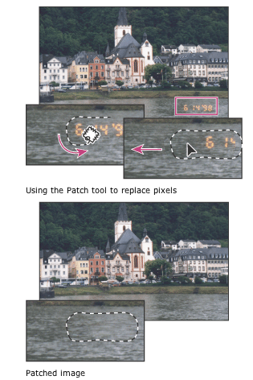

When repairing with pixels from the image, select a small area to produce the best result.
Using the Patch tool to replace pixels
Using the Patch tool to replace pixels
Patched image
Patched image

To repair an area using sampled pixels:

1. Select the Patch tool Patch tool .
2. Do one of the following:
* Drag in the image to select the area you want to repair, and select Source in the options bar.
* Drag in the image to select the area from which you want to sample, and select Destination in the options bar.

Note: You can also make a selection prior to selecting the Patch tool.
3. To adjust the selection, do one of the following:
* Shift-drag in the image to add to the existing selection.
* Alt-drag (Windows) or Option-drag (Mac OS) in the image to subtract from the existing selection.
* Alt-Shift-drag (Windows) or Option-Shift-drag (Mac OS) in the image to select an area intersected by the existing selection.
4. Position the pointer inside the selection, and do one of the following:
* If Source is selected in the options bar, drag the selection border to the area from which you want to sample. When you release the mouse button, the originally selected area is patched with the sampled pixels.
* If Destination is selected in the options bar, drag the selection border to the area you want to patch. When you release the mouse button, the newly selected area is patched with the sampled pixels.

To repair an area using a pattern:

1. Select the Patch tool Patch tool .
2. Drag in the image to select the area you want to repair.

Note: You can also make a selection prior to selecting the Patch tool.
3. To adjust the selection, do one of the following:
* Shift-drag in the image to add to the existing selection.
* Alt-drag (Windows) or Option-drag (Mac OS) in the image to subtract from the existing selection.
* Alt-Shift-drag (Windows) or Option-Shift-drag (Mac OS) in the image to select an area intersected by the existing selection.
4. Select a pattern from the Pattern pop-up palette in the options bar, and click Use Pattern.

This Ends this Session

Help & Revision material

Brush sizes
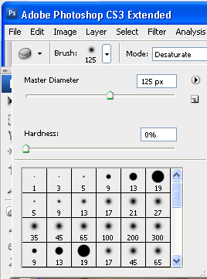
Note: It is useful to increase or decrease the brush size; select a brush type, soft edge hard edge or and effects brush... then use this slider
to change the size.
Drag the mouse over the image to check the size of the brush.

The Layers Palette

The Layers palette is your essential tool for working with layers. It contains a list of all your layers (referred to by name), starting with the topmost layer, and provides a thumbnail of the contents of each layer. Only one layer can be active at a time; the active layer is selected. You can use the Layers palette to perform many tasks (e.g., create, delete, hide, merge, and flatten layers).

To open the Layers palette:
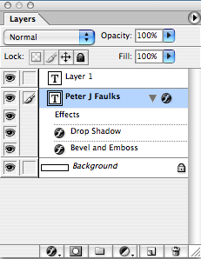

1. From the Window menu, Layers (F7)
The Layers palette appears on the Photoshop window.

To close the Layers palette:

From the Window menu, select Hide Layers
OR
Click the X in the upper right hand corner of the Layers palette
The Layers palette disappears from the Photoshop window into the dock – if you want you can drag the dock out onto the screen.

Note: The layer at the top of the list is the layer in front of all the other layers you can move (drag) layers up and down to get images in the correct stacking order.
Note you cannot move the background layer.

Add new layer style
Layer mask
Create a new set,
Create a new fill or adjustment layer
New layer
Trash delete layer

Hiding/Displaying Layers
You may find it useful to hide layers while working in Photoshop. For example, when merging layers, you can hide some layers so that they will not be merged. Visible layers have an EYE icon next to them, hidden layers do not appear when you save your work.

You can toggle between visible and hidden by clicking in the corresponding layer's Eye column.

Eyes shows or hides layer,
layer above is on top move up or down or add a new layer.

Help Note: Layer Selection Tips
When you select (i.e., click) a layer in the Layers palette, that layer is active. Review the following tips to learn about selection rules:

Only one layer can be active at a time, (highlighted in blue).

The name of the active layer appears in the title bar of the image window.

Changes affect only the active layer even though you view the whole image in the image window.

To hide several layers:
On the Layers palette, click the EYE icon corresponding to the layer(s) (and background) you wish to hide to select several layers click and drag within the Eye column to select the layers at once
These layers are now hidden.
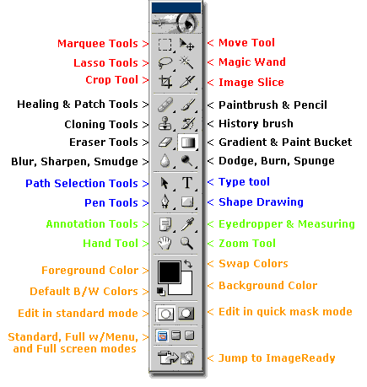

Photoshop Toolbox Reference
This section of the site is a comprehensive Photoshop Toolbox reference. Click on a tool to view its video-manual*.
Icon | Tool | Key | Purpose |  | Icon | Tool | Key | Purpose
 | Elliptical Marquee | M | selecting |  |  | Single Row Marquee | - | selecting
 | Rectangular Marquee | M | selecting |  |  | Single Column Marquee | - | selecting
 | Lasso | L | selecting |  |  | Move | V | transforming
 | Polygonal Lasso | L | selecting |  |  | Magic Wand | W | selecting
 | Magnetic Lasso | L | selecting |  |  | Crop | C | transforming
 | Slice | K | web design |  |  | Slice Select | K | web design
 | Healing Brush | J | retouching |  |  | Patch | J | retouching
 | Brush | B | painting |  |  | Pencil | B | painting
 | Clone Stamp | S | painting |  |  | Pattern Stamp | S | painting
 | History Brush | Y | restores to selected history state |  |  | Art History Brush | Y | painting
 | Airbrush | J | painting |  |  | Eraser | E | erasing
 | Background Eraser | E | erasing |  |  | Magic Eraser | E | erasing
 | Paint Bucket | G | painting |  |  | Gradient | G | painting
 | Blur | R | unfocusing |  |  | Sharpen | R | focusing
 | Smudge | R | painting |  |  | Sponge | O | color adjustment
 | Dodge | O | tonal adjustment |  |  | Burn | O | tonal adjustment
 | Horizontal Type | T | typing |  |  | Vertical Type | T | typing
 | Horizontal Type Mask | T | typing |  |  | Vertical Type Mask | T | typing
 | Direct Selection | A | drawing |  |  | Path Selection | A | drawing
 | Pen | P | drawing |  |  | Freeform Pen | P | drawing
 | Add Anchor Point | - | drawing |  |  | Delete Anchor Point | - | drawing
 | Convert Point | - | drawing |  |  | Rectangle | U | drawing
 | Rounded Rectangle | U | drawing |  |  | Ellipse | U | drawing
 | Polygon | U | drawing |  |  | LIne | U | drawing
 | Custom Shape | U | drawing |  |  | Eyedropper | I | choosing color
 | Color Sampler | I | color information |  |  | Measure | I | geometrical measurements
 | Notes | N | non-printable data |  |  | Audio Annotation | N | non-printable data
 | Hand | H | navigating |  |  | Zoom | Z | image viewing
 | Color Selecting box | - | displays current color |  |  | Color Replacement | J | retouching
 | Mode Selector | Q | selecting |  |  | Jump to Image Ready | Shift+  Ctrl+  M | web design

